LABORATORY VISUALIZATION PROJECT v1.0
Written by John W. Riggin III of the Technical Communications Group. TSC export Procedures provided by Craig J. Kaplan of the Plant Construction Group.

BACKGROUND

The Laboratory Visualization Project is a modeling and simulation system currently under development by the Technical Services Department’s Technical Communications Group. This project will address the Laboratory’s need to have access to a high-fidelity scale virtual model of the facilities and terrain of its 360-acre campus. Funded by the Laboratory’s Chief Facilities Engineer, this geo-spatial simulation and environmental visualization system will aid and enhance APL’s management’s decision-making process by visually representing proposed aesthetic changes for future campus development. This highly sought-after tool has also gained support and enormous interest from departments such as ADSD, NSAD, NSTD, PPSD, and certain groups within TSD.

MODEL MANAGEMENT

Initial development efforts have implemented a procedural taxonomic system for the multivariate data utilized for generation of the campus terrain model. Maintenance of this model is based predominantly on the ability to efficiently update the topographical data currently in the system, maximizing the projects development lifecycle. The data provided for changes will adhere to the following guidelines regardless of the originating source.

Software/Hardware

Currently, this system comprises several commercial-off-the-shelf software solutions put together in a more cohesive manner allowing for the accurate development of the model’s base terrain poly mesh geometry. As development continues, additional solutions or technologies may be utilized. The following is a list of products currently used for the development and maintenance of this project:

      - AutoCAD 2004
      - Adobe Photoshop
      - Macromedia Freehand MX
      - Alias Maya

The hardware infrastructure of this project is PC based using Dell 530 Precision workstations equipped with a minimum of Dual-Zeon 2.2 GHz processors, 4 GB of RAM, and a Nvidia Quadro4 900 XGL video card. Additional computers are utilized for final rendering. However, the current hardware configuration of this system is reaching maximum capability, even with the more robust workstations, particularly regarding rendering output and display feedback.

CAD Data Translation

The TSC group ultimately controls the master topographic and structural building plans that are the foundation of this project. Terrain meshes generated from this data are only as accurate as the data provided from TSC or their contractors. Data received from TSC or their contractors for inclusion into the existing modeling dataset will be continuous contours delivered in the AutoCAD DXF format along with all other layers such as roads, sidewalks, forested areas, etc.

The file will be generated with the procedures developed by TSC to ensure seamless integration with existing data in the current master topographical model and for maximum efficiency in creating topographical terrain revisions. The procedures are as follows:

DXF Export Process as of 24 NOV 2004:

1. Bind and Insert all Xrefs
2. Scale DWG to fit 1:1 letter sheet
3. Explode all blocks
4. Purge all including nested blocks
5. Run Utilities Audit
6. Copy entire DWG to clipboard
7. Start new DWG from DWT template
8. Paste DWG from clipboard to new DWG file
9. DXFOUT
10. Validate DXF using Freehand MX

NOTE: All steps are to be performed in AutoCAD 2004 using 2004 DWG formatting.

Master Topographical Model

The topographical contours for this model will be generated in Freehand MX from the AutoCAD DXF file provided from TSC or an outside architectural development contractor. Topographical contours will be provided in one-foot intervals or less if APL’s Chief Facility Engineer requires a higher level of fidelity for terrain visualization. Every fifth contour will be placed on a layer separate from the incremental one-foot contours. Each contour will be a continuous poly-line. In the event that a contour intersects a building or structure, the contours shall be joined to the corresponding adjacent contour by using the uphill footprint portion of the building to complete the line. The line attributes will be solid non-dashed and one point in thickness. The Freehand file generated from the DXF data will be considered the projects master topographical model.

Scalar Height-Field Model

The following method will be used to create the scalar height-field model. This model will be developed as incremental one-foot grayscale taxonomy. The height-field model will originate from the master topographical model and will be saved as a new scalar height-field model. The base layer of this hierarchical arrangement will represent the lowest terrain elevation in the final campus model. The continuous contour for the base elevation will be duplicated from the master topographical model’s lowest contour, assigned to a new layer, labeled descriptively with the elevation and value, and filled with the RGB vector value of (0,0,0). The process will be repeated incrementally through the highest elevation on the property – currently 449 feet above sea level. Fifty-one feet in additional elevation have been accounted for in this model and are still available for additional development.

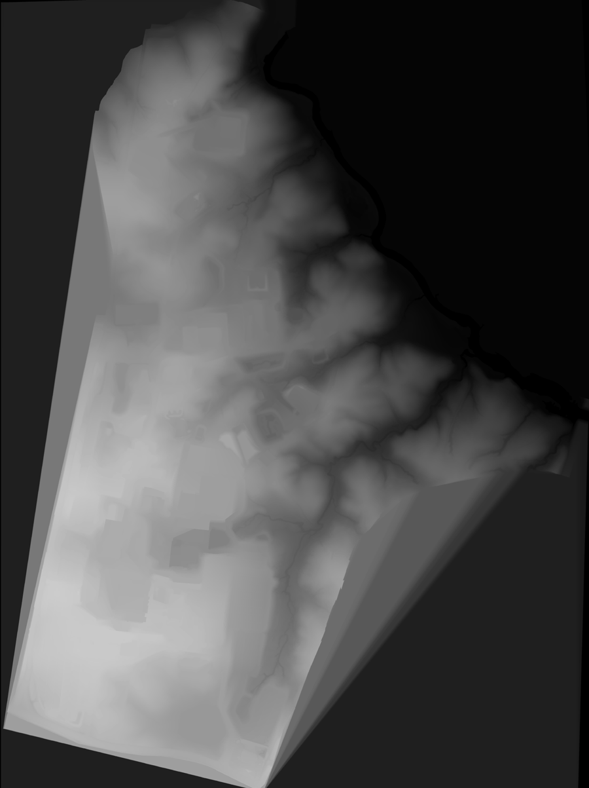
Lowest terrain elevation
245’ = 0,0,0 RGB Vector value

One-foot increment
246’ = 1,1,1 RGB Vector value

Maximum possible terrain elevation
500’ = 255,255,255 RGB Vector value

Holes will be punched in upper layers dictated by topographical features designated in the master topographical model, allowing for the lower elevations terrain visibility. After filling and punching has occurred, the layers line weight will be set to none. The image to the right represents a complete height-field model using the described procedures and values.

Upon completion of the height-field model’s development, two files will be exported out of Freehand MX and saved as 144-dpi PSD files—the maximum resolution due to current hardware limits. The first file exported will be the grayscale height-field model without an alpha channel and the second file will be a duplicate of the master topographical model with alpha channel.

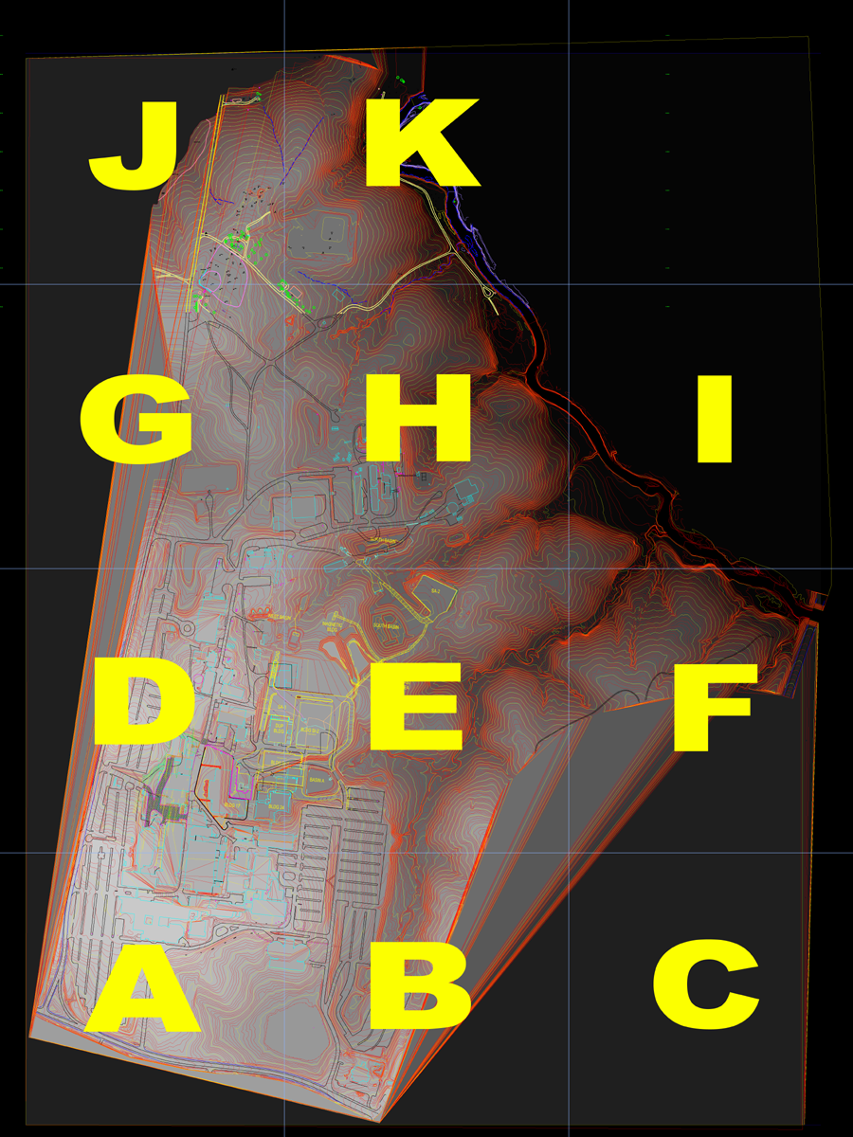
The files will then be opened in Photoshop and layered, forming a master displacement file. From this composite, the terrain will be broken down into grid sections. The current grid implemented is based on a13 ×13-inch division creating three equal sections from West to East and four equal sections from North to South. The individual sections are alphabetically coded A thru K. This grid can be subdivided if higher fidelity terrain generation is necessary.

NOTE: Current divisions may change based on the Maryland Geographic Coordinate System and area of greatest campus development.

From the divisions, individual height-field displacement files will be created with an overlap of .25 inch into the adjacent sections. The sections will be cropped and saved as TIFF displacement maps for terrain mesh model creation.

Terrain Mesh Model

The terrain mesh model will be generated based on the designated grid implemented within the master Photoshop displacement file. Within Maya, Non-Uniform Rational B-Spline planes will be created with a width of 13.25 representing the size of the output displacement files from Photoshop. The length ratio will be set to 1 and a surface patch tessellation of 20 will be assigned as this setting has been found to produce acceptable results. The individual planes Displacement Map attributes shall be set as follows:

Feature Displacement selected
Initial Sample Rate = 40
Extra Sample Rate =3
Texture Threshold = 2
Normal Threshold = 5
Vector values for Bounding Box Scale all = 1.5

The individual sections will then be modified displacing the surface planes to polygons. Boundary edges will then be aligned and overlapping terrain matched. The overlapping internal boundary edges will then be cut, forming seamless13 ×13 Maya unit grid sections. The individual terrain meshes will then be labeled and grouped. The group will then be labeled and the pivot point centered. This group will then be scaled in the y-axis for appropriate vertical exaggeration. Vertical exaggeration will be measured for scale and accuracy.

Additional levels-of-terrain detail will be created based on the prior algorithmic steps; however, appropriate values for the additional levels-of-terrain detail have only been investigated as far as the proof-of-concept stage of development and not for usable results. Once these values have been established, a real-time level-of-detail terrain model will be implemented to aid in display and output efficiency.

Texture Maps

Surface texture maps will be created in Photoshop. These maps will be based on the master topographic model export with alpha channel from Freehand MX. The exported data file will serve as a template for creating two-dimensional aesthetic surface features and appropriate placement of the campus models physical infrastructure. The texture maps created in Photoshop will be cropped and saved as 13 ×13 high-resolution TIFF images. These files will be appropriately labeled to correspond to the relevant terrain mesh’s geometry. These maps will then be place onto their corresponding section within the terrain mesh model. The combination of terrain meshes and surface textures will be saved as a campus model.

NOTE: In the event that a real-time level-of-detail model is implemented, lower resolution surface textures will be created to complement the corresponding lower resolution geometry.

Updates

The time required to update the model will be based on the complexity of the changes, the amount of vertical elevation that the changes encompass, and the sections of terrain affected by the update. Given that the data provided for change meets the specifications set forth in this document, a projected timeframe of one to three weeks maybe necessary to complete the changes based on the entire algorithm described previously.

ADDITIONAL DEVELOPMENT

Because of the procedural nature of this project, advancement of capability, and the constant implementation of a more robust hardware infrastructure, this project will continue to evolve. And as we refine the process, this document will be updated and redistributed to all stakeholders.

